3GPP TSG RAN WG1 #125 R1-2604314
Dalian, China, May. 18th ~ 22nd, 2026
Source: MediaTek Inc.
Title: Discussion on sensing aspects of integration with communication
Agenda item: 10.8.2
Document for: Discussion

Introduction
In the RAN#108 meeting, a new study item on 6GR SID was approved, which includes the sensing study as listed following [1]:
- Sensing – Studies to be based on use cases and associated requirements, as defined in [TR38.914]
- PHY functions and procedures for sensing technology (e.g., waveform. reference signals, measurement feedback, etc…) [RAN1, RAN4]
- Evaluate sensing performance and if necessary, extend channel modelling, for the selected use cases [RAN1]
- Aspects of integration with communication services [RAN1]
- higher layer procedures and protocol aspects [RAN2]
- RAN4 aspects of sensing including RF, coexistence, and testability in coordination with other WGs [RAN4]
Note: RAN1 identify detailed requirements, if triggered by TSG RAN

Based on RAN1 Chair’s guidance, the following scope will be considered at this sensing agenda [2].
- Including proposals for reusing and dedicated reference signal based on waveforms for communications, measurement and report for different use cases, etc. (could be part of AI 10.5.3)

This agenda was extensively discussed at last meeting, some agreements were achieved during the discussion, which is relevant with RS design, sensing measurement and reporting, etc, and the details can be found at RAN1 Chair Notes [2].
Based on the FL’s plan on this agenda, the following sensing evaluation aspects will be discussed with higher priority at this meeting [3]:
- Usage scenarios for sensing assisted communication.
  - Note: this doesn’t mean we want to directly specify anything. We need RAN1 views on communication assistance which is required by RAN. To justify a usage scenario, either evaluation (10.8.1) or analysis can be considered.
  - Note: after clarification on the usage scenarios, it is possible that they are merged with object detection/tracking in respective discussions.
- RS design
  - Please elaborate designs on sensing RS especially the RE patterns.
  - Please provide evaluations/analysis.
- Measurement/report
  - Measurement definitions/levels for TRP-side and UE-side measurements, taking into account the impact of non-ideal factors.
  - Views on key issues of measurement reporting mechanisms.
- Based on discussions in this meeting (though no agreements yet), the inputs on the following aspects can be considered which is up to each company.
  - Resource allocation/multiplexing
  - Phase continuity within a CPI
  - Beam related sensing operations
  - Interference handling
  - Power control
  - Timing advance
  - Sensing Tx/Rx node selection, if any, from RAN1 perspective
  - Start/end/activation/deactivation of sensing operations, if any, from RAN1 perspective

In this contribution, we will further provide our views on 6G sensing RS design, measurement/reporting, procedure, etc, based on the discussion status of last meeting, and the RAN1 Chair’s guidance and FL’s plan.

Discussion

General aspects
Sensing is an advanced technology that leverages radio frequency signals to detect and analyse the physical environment by measuring how electromagnetic waves bounce off objects. It enables the network to accurately determine the range, velocity, angle, and even micro-movements of targets purely based on signal reflections. Ultimately, as a core feature of 6G, it transforms traditional communication networks into intelligent, dual-purpose infrastructures being capable of both transmitting data and continuously perceiving the physical world.
For 3GPP cellular sensing operation, it is expected that the communication device also can conduct sensing operation, which means a sensing only device is not preferred from 6GR standard perspective, and 6G communication is a key enabler for 6GR system design and future commercial landing. Thus, it is natural to leverage the communication design to conduct sensing operation if it can meet sensing requirement, which is cost-efficient mechanism for ISAC system design. In other words, if some sensing scenarios can be achieved by directly reusing the communication design, the motivation for introducing new sensing dedicated design is not clear. If some sensing scenarios/requirements cannot be achieved by directly reusing the communication design, we can further discuss the enhancement solutions or sensing dedicated solution within the cellular system scope.
In addition, based on the updated 6GR plan [4], it can be seen that the potential RAN1 meeting schedule for sensing is from 2026/April to 2027/February, which means only five meetings are left for 6G RAN1 sensing study after April meeting, and the meeting time is very limited. Thus, a reasonable scope for sensing discussion is needed.
Observation 1: The meeting time for 6G sensing study is very limited, i.e., only five RAN1 meetings are left.

Proposal 1: The design of sensing shall be based on the principle of maximally reuse communication design to meet sensing requirements.

Sensing mode
Based on the different sensing entity, e.g., UE or TRP, and whether the sensing entity is as a sensing transmitter and/or sensing receiver, it can be classified into six basic sensing modes as illustrated in Figure 1, i.e., TRP monostatic sensing mode, TRP-TRP bistatic sensing mode, TRP-UE DL bistatic sensing mode, UE-TRP UL bistatic sensing mode, UE-UE bistatic sensing mode, and UE monostatic sensing mode.
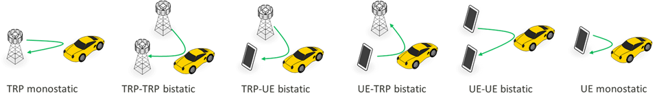
Figure 1 sensing modes
At the 5G-A sensing study phase, TRP monostatic sensing has been studied for UAV scenario [5], which evaluates the feasibility of using TRP monostatic sensing to detect and/or track the UAV with typical parameters configuration/assumption.
Observation 2: TRP monostatic sensing mode has been studied at 5G-A sensing.
For the 6GR sensing, supporting more sensing modes were proposed, and it was agreed that 6GR sensing study shall include all six sensing modes at RAN#109 meeting.
6GR should study the sensing modes, including TRP monostatic, TRP-TRP bistatic, TRP-UE DL, UE-TRP UL, UE-UE bistatic and UE monostatic

Observation 3: RAN Plenary has agreed 6GR should study the sensing modes, including TRP monostatic, TRP-TRP bistatic, TRP-UE DL, UE-TRP UL, UE-UE bistatic and UE monostatic.
Each sensing mode offers distinct advantages and may play complementary roles in enhancing the overall system’s sensing capabilities. Particularly, for UE-involved bistatic sensing mode, the presence of numerous flexible candidate UEs within the cell coverage enables sensing range extension compared to TRP monostatic sensing mode alone, and it also can maximally reuse the communication design for efficient sensing. By supporting UE involved sensing mode, ISAC can support flexible in node selection, expand sensing coverage, improve sensing accuracy, and better adapt to diverse application scenarios.
Proposal 2: Prioritize UE involved sensing mode at 6GR sensing study phase.

RS design
Regarding the sensing RS design, it was extensively discussed at last meeting, and the following agreement was achieved [2]:
Agreement:
- On RS for ISAC, study at least the following aspects, considering sensing performance, resource overhead and impact to communication
  - RS for communication is reused for sensing
  - Enhanced RS for sensing, taking reuse of RS for communication as starting point
    - Note: Part of or all of the RS may be used for communication purpose, and it does not mean the final decision on whether the enhanced RS is used for communication purpose is to be made in this agenda.
  - Dedicated RS for sensing

Agreement:
- Study RE patterns of RS for sensing, considering sensing performance, resource overhead and impact to communication
- Note: enhancements on RS sequence if any will be discussed in agenda 10.8.3

As agreed above, when studying the sensing RS design, the sensing RS/resource overhead is one of key consideration factor. However, there is no clear definition on sensing RS/resource overhead at 6GR sensing. The issue was discussed at 5G-A sensing evaluation phase, but, due to controversial views and limited meeting time, particularly regarding whether resources used for both sensing and communication should be considered as sensing overhead, a consensus was difficult to be reached. As a compromise, two options for defining the sensing resource ratio were agreed, and it is left to each company to decide which option to be adopted [6].
………………………..
The evaluation assumptions for the evaluation of UAV use case with gNB-based monostatic sensing are provided in Annex A. In order to define the sensing resource ratio used in the evaluation of NR ISAC, three kinds of resources are defined
- Type_1: Resources that are used for sensing signal transmission
- Type_2: Part of Type_1 resources that are used for communication purpose
NOTE: It is possible the Type_2 resource doesn’t exist.
- Type_3: Resources that are not used for sensing signal transmission, and cannot be used for communication purpose due to sensing operation
Two options are provided to calculate the sensing resource ratio. Both options should be reported by companies.
- Option 1: (Type_1 + Type_3) resources over all radio DL and UL resources
- Option 2: (Type_1 - Type_2 + Type_3) resources over all radio DL and UL resources
NOTE: If Type_2 resource doesn’t exist, two options are the same
………………………..

Observation 4: Two sensing resource ratios are defined at Rel-20 5G-A ISAC discussion.

For 6G sensing, especially for sensing RS design, reducing sensing RS overhead while meeting the sensing service requirement is key direction since higher sensing RS overhead will impact the communication efficiency/performance as mentioned above. From this perspective, a clear sensing RS/resource overhead definition is suggested.
Regarding whether the above type-2 resource is a sensing RS/resource overhead or not, if the sensing RS is used for communication purpose, which means the RS also contributes the communication performance, it is not suitable to call it as an additional overhead. Therefore, we prefer the option 2 definition of sensing resource ratio at TR 38.765 as 6G sensing RS/resource overhead.
Proposal 3: For 6G sensing RS/resource overhead definition, option 2 definition of sensing resource ratio defined at 5G-A ISAC is suggested, i.e., only resource which cannot be used for communication due to sensing operation is considered as sensing overhead.

As agreed, the study of sensing RE patterns for sensing shall consider how to lower sensing resource overhead and reduce impact to communication, while meeting sensing performance. Given that existing communication RS designs employ uniform structures in time and frequency, a straightforward choice for sensing RE patterns is to adopt a similar uniform pattern. To meet sensing performance requirements such as range resolution and Doppler resolution, the sensing signal typically requires wide bandwidth in the frequency domain and long observation duration in the time domain. Furthermore, in a uniform pattern, the maximum unambiguous range and maximum unambiguous Doppler are determined directly by the sampling density in frequency and time, respectively. Consequently, satisfying these requirements require a large number of subcarriers and OFDM symbols, making the resource overhead directly proportional to the needed maximum range and Doppler values, and to the required range and Doppler resolution. In multi-antenna (multi-port) scenarios, this overhead further increases linearly with the number of antenna ports.
Observation 5: Due to its strict structure, the uniform pattern results in an inefficient trade-off between sensing performance and resource overhead, without optimizing the impact on communication. Specifically, improving range or Doppler performance means the pattern uses many more subcarriers or symbols across the entire allocated bandwidth and duration.
The uniform pattern lacks the flexibility to adapt to the dynamic resource environment of an ISAC system. Its practical allocation faces fundamental challenges due to the existence of resources unavailable for sensing. For example, in a TDD system, uplink slots prevent the transmission of downlink sensing RS, while downlink slots similarly restrict uplink sensing. This TDD slot structure creates unavoidable gaps in time-domain sampling, making it impossible for a uniform pattern to achieve the continuous, high-density symbol placement required for unambiguous Doppler estimation of high-speed targets. Furthermore, co-existing scheduled or high-priority signals can occupy resource blocks in the frequency domain, creating gaps that break the uniform comb structure needed for unambiguous range estimation. The presence of these sampling gaps in the time or frequency domain prevents the allocation of a pure uniform pattern, making non-uniform sensing RS patterns a necessary alternative. Without careful design, such gaps would cause significant sensing performance degradation.
Observation 6: In practical ISAC deployments, a uniform pattern is often infeasible. Specifically, TDD slot boundaries and resource conflicts with other signals create unavoidable gaps in time-frequency sampling. These gaps prevent a high-density, wide-span uniform pattern from satisfying the required sensing performance.
To overcome the limitations of the uniform pattern, the study of non-uniform sensing RS patterns is necessary. Such patterns are required to reduce overall resource overhead while maintaining essential sensing performance. Non-uniform designs offer the flexibility needed to adapt to dynamic resource availability, optimize time-frequency resource utilization, and mitigate the ambiguity challenges inherent in low-overhead uniform sampling. Consequently, non-uniform sensing RE pattern design is an essential study item for effectively balancing sensing performance with resource overhead and impact on communication.
Numerical examples: Below is two simple examples demonstrating the benefits that can be gained from the well-designed nonuniform pattern.
Example 1: Comparison of 2D Uniform and Nonuniform RE pattern
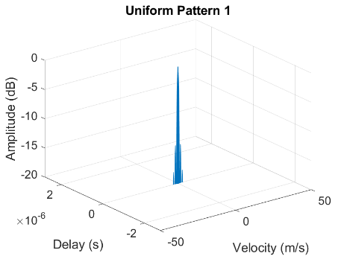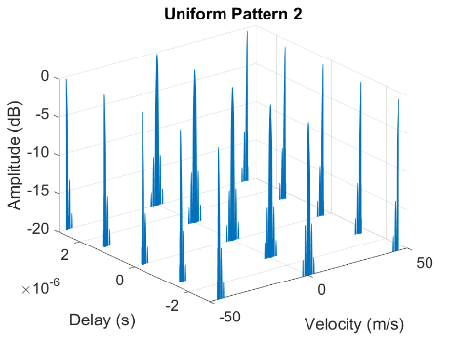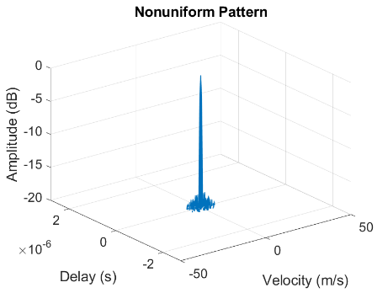

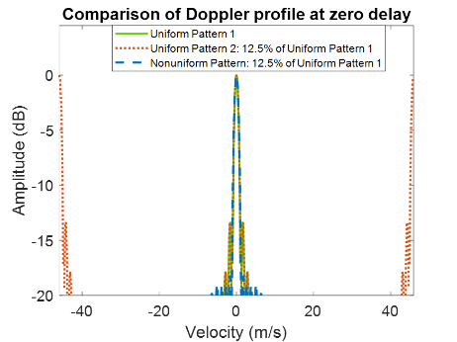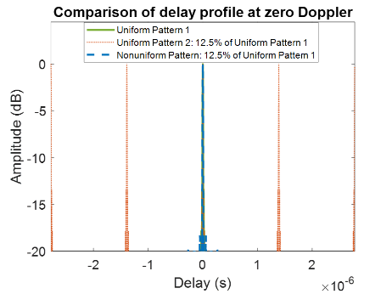
Scenario: Carrier frequency: 7 GHz, BW: 100 MHz, subcarrier spacing: 30 KHz, CPI: 20 ms
Uniform Pattern 1: Uses a comb-6 structure in the frequency domain and a sensing RE density of one RE per 7 OFDM symbols in the time domain.
Uniform Pattern 2: Based on Uniform Pattern 1, this pattern reduces frequency density with a comb-24 structure and also reduces time-domain density to one sensing RE per slot, resulting in a total overhead of 12.5% compared to Uniform Pattern 1.
Non-uniform Pattern: This pattern selects a non-uniform set of sensing REs that collectively occupy 12.5% of the resources defined in Uniform Pattern 1. It maintains the same overhead as Uniform Pattern 2.
Key result:
A well-designed non-uniform pattern, achieving approximately 86.5% overhead reduction, can maintain a delay-Doppler power spectrum with 3 dB main lobe beamwidth and peak sidelobe (PSL) levels comparable to a uniform pattern.
At the same overhead level, significant improvement in maximum unambiguous range and velocity can only be achieved through the use of non-uniform RS design.
Observation 10: Nonuniform sensing RE pattern can significantly reduce resource overhead while maintaining maximum unambiguous range and Doppler as well as range and Doppler resolution comparable to those of uniform pattern.
Observation 11: By careful design, nonuniform pattern can achieve the sharp main lobe HPBW and low PSL at a low overhead and enable efficient processing without resorting to computationally intensive super-resolution algorithms.

Example 2: Sensing signal placement in TDD channel
D
D
D
S
U
D
D
S
U
U
slot 0
slot 1
slot 2
slot 3
slot 4
slot 5
slot 6
slot 7
slot 8
slot 9

Scenario: Carrier frequency: 7 GHz, subcarrier spacing: 30 KHz, CPI: 20 ms, TDD pattern: DDDSUDDSUU
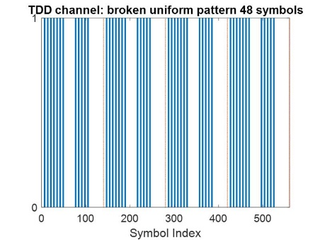 | 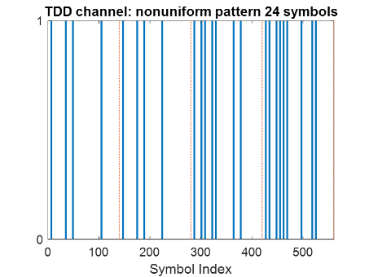 | 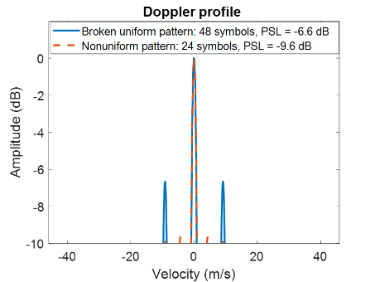
Requirement: To achieve a maximum unambiguous velocity of ±46 m/s, a uniform sensing pattern requires a time density of one sensing RE every 7 OFDM symbols.
Key results:
In TDD deployment, the presence of switching and uplink slots creates unavoidable gaps in this time-domain uniform pattern, notably degrading the Doppler response for downlink sensing. Specifically, a regular pattern occupying one out of every 7 symbols across only available half-slots (a total of 48 symbols) suffers from high Doppler sidelobes of -6.6dB.
A nonuniform pattern with a careful design can reduce the high sidelobes generated by the gaps with also a 50% reduction of occupied sensing symbols.
Observation 7: A non-uniform sensing pattern can reduce performance degradation caused by gaps in unavailable time-frequency resources and enhance compatibility with coexisting communication signals, all while reducing overall resource overhead.
Proposal 4: Study non-uniform sensing RE patterns in the frequency and/or time domain to meet sensing performance while reducing resource overhead and impact to communication.

Resource allocation
Resource multiplexing between sensing and communication signals can be performed across multiple domains: time, frequency, angular, joint time–frequency, and more general high-dimensional signal spaces. The allocation of these resources should satisfy sensing performance requirements while reducing the impact on communication performance as much as possible.
For TDM-based ISAC, the core challenge is efficiently multiplexing sensing and communication resources within the time domain under distinct performance requirements of both functions.
Observation 8: Current implementations of TDM-based ISAC are constrained by the communication-centric 5G frame structure (slot/half-slot granularity), restricting sensing into rigid, pre-defined time windows with limited flexibility.
Beyond one-dimensional resource allocation, sensing can be done with high dimensional signal spaces. Both allocation and signalling mechanisms for multidimensional sensing resource allocation shall be optimized and improved over 5G limitations.
Observation 9: The traditional indication on sensing RS/resource may not be efficient in terms of signalling overhead, especially for irregular RS/resource indication.
Various sensing tasks impose distinct requirements on radio resources. Consequently, sensing-resource allocation must be flexible enough to adapt to those requirements and configurable through only a few task-specific parameters, eliminating the need for exhaustive table lookups or excessive signaling. The pattern also needs to be repeatable: a deterministic mapping from the parameters to the resource pattern guarantees consistent performance across repeated runs of the same task.

Proposal 5: Study efficient sensing resource allocation and signalling mechanisms, e.g., sensing resource allocation should be flexibly configurable.

Measurement
Regarding sensing measurement, it was discussed at last meeting, and the following agreement was achieved [2]:
Agreement:
- On measurement for ISAC, study at least the following aspects.
  - Measurement definitions/levels for TRP-side measurement, taking the measurement Levels studied in NR ISAC as starting point
  - Measurement definitions/levels for UE-side measurement
  - Impacts of non-ideal factors on measurement
  - Other aspects are not precluded
  - Note: this discussion may or may not mean there is specification impact

During the 5G-A sensing evaluation phase, only the TRP monostatic mode is considered. Accordingly, sensing measurement levels are defined only for the TRP side. For 6GR sensing, six sensing modes are under study, and sensing measurements may be performed on either the TRP side or the UE side. In the last meeting, it was agreed only that the existing NR measurement levels could be used as an initial basis for TRP-side measurements. For UE-side measurements, however, all sensing measurement levels may also be considered as a baseline, since UE capabilities vary across different UE types, such as handheld UEs, CPE UEs, and RSU UEs.
Proposal 6: For UE side measurement, taking all the measurement levels studied in NR ISAC as baseline.

Reporting
Regarding sensing measurement reporting, it includes some key design points, e.g., who to report, where to report, how to report, etc, these issues were discussed at last meeting, and the following agreements were achieved [2]:
Agreement:
- On measurement report for ISAC, study at least the following aspects and applicable scenarios (e.g., sensing modes, targets, etc.) from RAN1 perspective.
  - Measurement reporting mechanism from UE
    - Option 1A: The UE measurements and/or assistance information if needed from UE can be directly sent to aNB
    - Option 1B: The UE measurements and/or assistance information if needed from UE can be sent to SF
  - Measurement reporting mechanism from aNB
    - Option 2A: The aNB measurements and/or assistance information if needed from aNB can be directly sent to UE
    - Option 2B: The aNB measurements and/or assistance information if needed from aNB can be sent to SF
  - The study may require cross-WG coordination.
  - Note: combination of multiple options is not precluded.
  - Note: measurements in each option may be different

Agreement:
- On measurement report for ISAC, study impacts from at least the following aspects from RAN1 perspective
  - Measurement reporting mechanism
    - E.g., Periodic, semi-persistent, aperiodic, event-triggered report as starting point
    - Reporting signaling e.g., L1, L2, higher layer, etc.
  - Other aspects are not precluded
  - The study may require cross-WG coordination.

Considering that the communication agenda will discusses channel feedback reporting mechanisms capable of providing per-path channel information, e.g., delay, Doppler, etc, this reporting is quite like certain sensing measurement reports. From this perspective, it is feasible to support a unified measurement reporting mechanism for both sensing and communication, which also can reduce redundant reporting. Based on this, the following proposal is suggested.
Proposal 7: At least support one measurement reporting mechanism unified with communication, i.e., one reporting for multiple purpose.

Procedure
For sensing operation, even for the same sensing target, the sensing requirement may be change while conducting sensing. For example, a sensing task may initially involve detecting a target, followed by tracking it. These two sub-tasks can have different sensing requirements, necessitating the reconfiguration of corresponding sensing resources. Therefore, it is recommended to study two-stage or multi-stage sensing procedures.
Observation 10: Sensing operation can be changed due to varying sensing demands, e.g., from detection to tracking, from coarse beam estimation to finer beam estimation.
Proposal 8: Study two-stage/multi-stage sensing procedure.

For 6G sensing, the UE can be not only as a sensing entity performing sensing operations, but also act as a sensing service consumer, which is also within the scope of SA2 [7].
e. Exposure framework of sensing result to the Sensing service consumer (i.e. AFs, UEs, Core NFs).
Thus, the UE can initiate a sensing service request, after which the network may select an appropriate sensing entity, allocate necessary sensing resources, and activate the sensing entity to carry out the sensing operations. Notably, the UE that initiates the sensing service request may or may not serve as the sensing entity itself.
Proposal 9: Support UE-initiated sensing mechanism. FFS on details.

Typically, if there is no data traffic to be delivered for the UE, it may enter RRC non-connected mode for better power saving, especially during nighttime. However, in certain sensing scenarios, e.g., intruder detection or human respiration monitoring, etc, it may be necessary for the UE to perform sensing operations at night. If the UE is required to frequently wake up and enter RRC CONNECTED mode for sensing, this can negatively impact its power consumption. Thus, it is suggested to study how to support sensing operation when sensing entity is in RRC non-connected mode.
Proposal 10: Study how to support sensing operation when sensing entity is in RRC non-connected (e.g., idle) state.

Conclusion
In this contribution, it discusses the 6G sensing aspects of integration with communication with the following observations and proposals:
Observation:
Observation 1: The meeting time for 6G sensing study is very limited, i.e., only five RAN1 meetings are left.
Observation 2: TRP monostatic sensing mode has been studied at 5G-A sensing.
Observation 3: RAN Plenary has agreed 6GR should study the sensing modes, including TRP monostatic, TRP-TRP bistatic, TRP-UE DL, UE-TRP UL, UE-UE bistatic and UE monostatic.
Observation 4: Two sensing resource ratios are defined at Rel-20 5G-A ISAC discussion.
Observation 5: Due to its strict structure, the uniform pattern results in an inefficient trade-off between sensing performance and resource overhead, without optimizing the impact on communication. Specifically, improving range or Doppler performance means the pattern uses many more subcarriers or symbols across the entire allocated bandwidth and duration.
Observation 6: In practical ISAC deployments, a uniform pattern is often infeasible. Specifically, TDD slot boundaries and resource conflicts with other signals create unavoidable gaps in time-frequency sampling. These gaps prevent a high-density, wide-span uniform pattern from satisfying the required sensing performance.
Observation 7: A non-uniform sensing pattern can reduce performance degradation caused by gaps in unavailable time-frequency resources and enhance compatibility with coexisting communication signals, all while reducing overall resource overhead.
Observation 8: Current implementations of TDM-based ISAC are constrained by the communication-centric 5G frame structure (slot/half-slot granularity), restricting sensing into rigid, pre-defined time windows with limited flexibility.
Observation 9: The traditional indication on sensing RS/resource may not be efficient in terms of signalling overhead, especially for irregular RS/resource indication.
Observation 10: Sensing operation can be changed due to varying sensing demands, e.g., from detection to tracking, from coarse beam estimation to finer beam estimation.

Proposal:
Proposal 1: The design of sensing shall be based on the principle of maximally reuse communication design to meet sensing requirements.
Proposal 2: Prioritize UE involved sensing mode at 6GR sensing study phase.
Proposal 3: For 6G sensing RS/resource overhead definition, option 2 definition of sensing resource ratio defined at 5G-A ISAC is suggested, i.e., only resource which cannot be used for communication due to sensing operation is considered as sensing overhead.
Proposal 4: Study non-uniform sensing RE patterns in the frequency and/or time domain to meet sensing performance while reducing resource overhead and impact to communication.
Proposal 6: For UE side measurement, taking all the measurement levels studied in NR ISAC as baseline.
Proposal 7: At least support one measurement reporting mechanism unified with communication, i.e., one reporting for multiple purpose.
Proposal 8: Study two-stage/multi-stage sensing procedure.
Proposal 9: Support UE-initiated sensing mechanism. FFS on details.
Proposal 10: Study how to support sensing operation when sensing entity is in RRC non-connected (e.g., idle) state.

Reference
- RP-251881, “New SID: Study on 6G Radio”, NTT DOCOMO (Moderator), June,2025.
- RAN1 Chair Notes for RAN1#124bis, April 2026.
- R1-2602592, Summary #4 on integration with communication for ISAC, Moderator (Xiaomi), April, 2026
- R1-2601173, Workplan for Rel-20 Study of 6GR NTT DOCOMO, China Mobile, AT&T, Vodafone.
- RP-251861, New SID: Study on Integrated Sensing And Communication (ISAC) for NR, AT&T(Moderator), June, 2025.
- 3GPP TR 38.765, Study on Integrated Sensing And Communication (ISAC) for NR.
- S2-2511308, Detailed FS_6G_ARC Work Task scopes, November 2025.

